**Opzet Werkwijze t.a.v. Demontage Groep t.b.v. BAYER-SWISS**

1. Select ‘’Polyline” at toolbar

1. Make Polyline around parts that will be removed.
2. ‘’Close’’ the Polyline
3. Select “Hatch” at toolbar

1. Select “Solid”
2. Make “Hatch Transparency” 50 %
3. Select “Select” to “Pick Points” inside the area of the Polyline
4. Select “Close Hatch Creation”

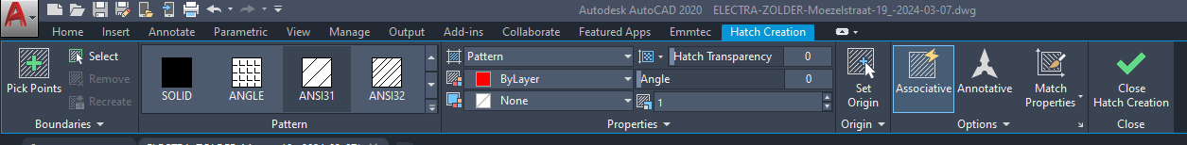

1. Put the Hatch and the Polyline at a separate Layer
2. Put the Hatch in the background:
3. Select the Hatch (a blue dot can be seen) 🡪 with the right mouse button 🡪 select “Draw Order” 🡪 “Send to Back”

1. Every “Demontage Groep = DG” (closed Polyline with Hatch) has its own Color.
2. At the PID there are ONLY DG’s, no Demontage Flanges (DF’s).
3. The DF’s are at the separate document of the DG.